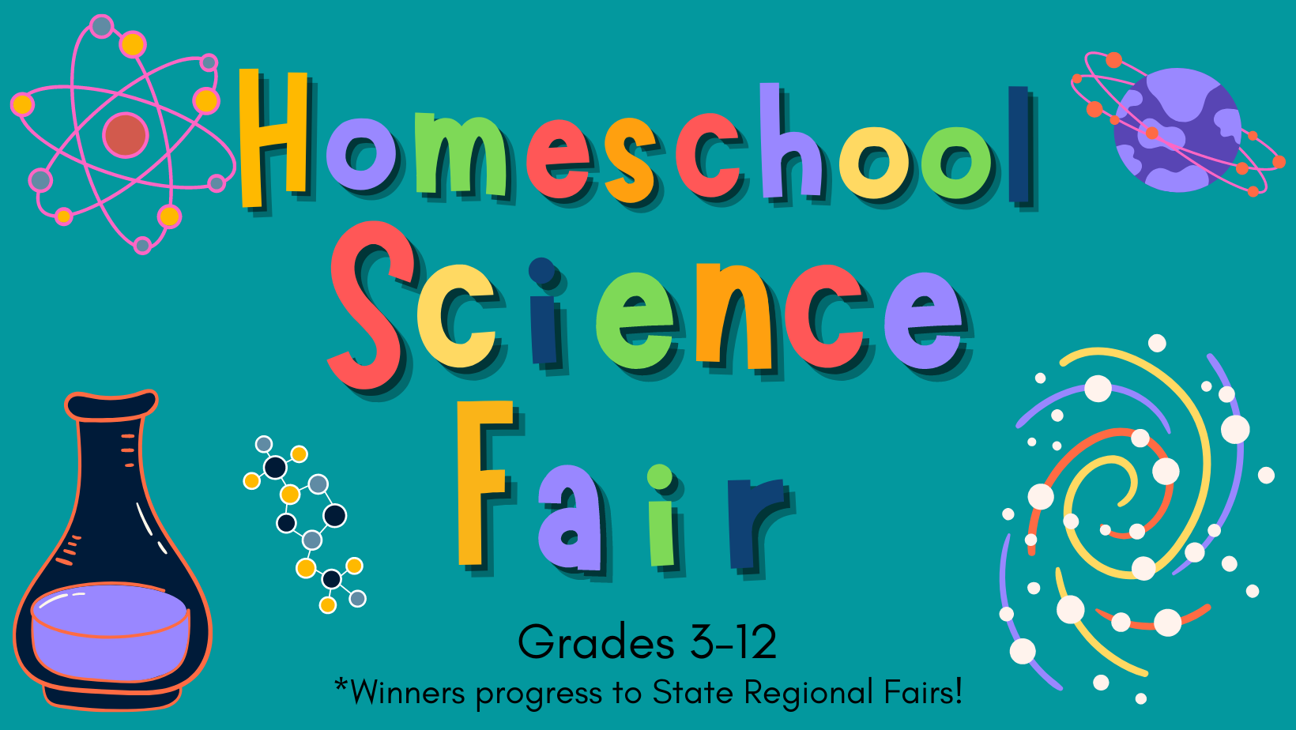

Student Packet

Table of Contents

**Introduction 1**

**Getting Started 2**

Types of Projects 2

The Scientific Method 3

Choosing a Category 4

Making a Good Question 5

Guide to Research &Hypothesis 6

Recording My Own Research & Hypothesis 7

Steps to Doing the Experiment 8

Steps to Collecting Data 9

Materials, Variables, and Procedures 10

Recording Data 11

Display 12

**Log Book Instructions 13**

Log Book Checklist 14

**Written Report Instructions 15**

**Science Fair Project Rubric 16**

Introduction:

It’s time for the Science Fair! We are excited to have you & your student participate. Please read the guidelines carefully and do your best work. There will be prizes for different age categories and winners will be promoted to regional and possibly statewide competitions.

You may ask “Why should our students do projects?” Science fair projects help to promote critical thinking, problem solving, and research. Not only that, but it is also interdisciplinary. This means that you do a little bit of every core subject when you complete a science fair project. Your written portions consist of ELA concepts. Your charts and graphs consist of mathematical concepts. Your research of the scientists who may have worked on something similar to your project consist of social studies/history concepts. There is so much to gain from working through and completing a science fair project!

High school students who produce impressive findings are sometimes scouted by colleges for further research into their chosen topic and field. This is an incredible opportunity for any student.

*Students 6-12 grade should use the Official UGA Science Fair Guidelines when creating their projects. Winners of our fair will be expected to submit based on these guidelines if they wish to progress to the next competition.

These official guidelines are available both on the Unite Homeschool Science Fair Page and at: [Georgia Science and Engineering Fair at UGA](https://www.georgiacenter.uga.edu/youth/academic-special-programs/georgia-science-and-engineering-fair)

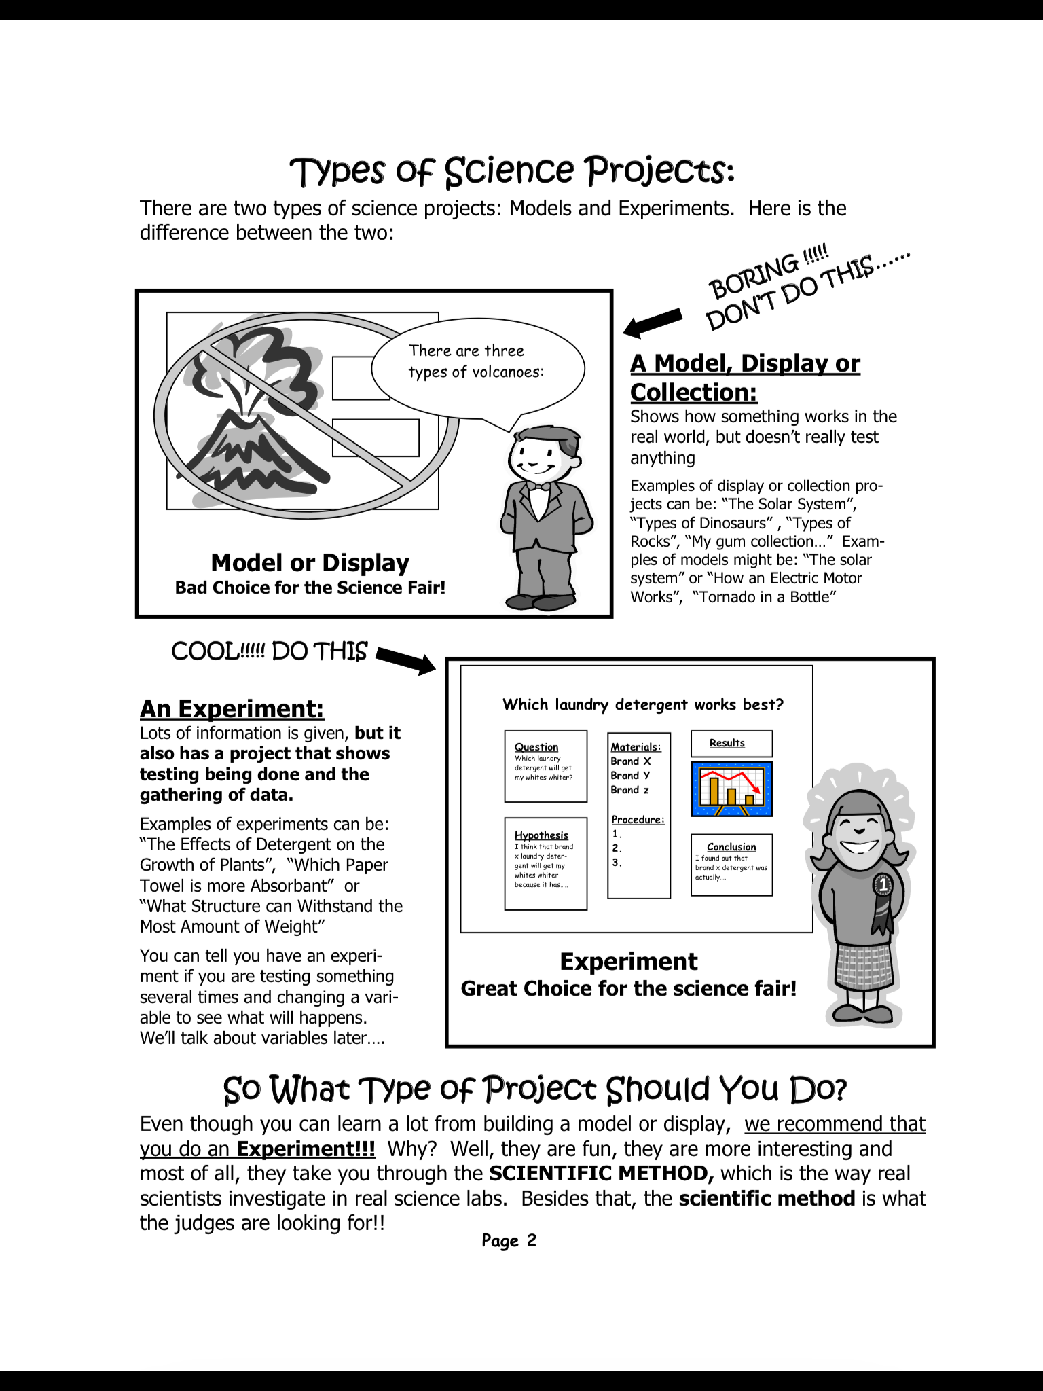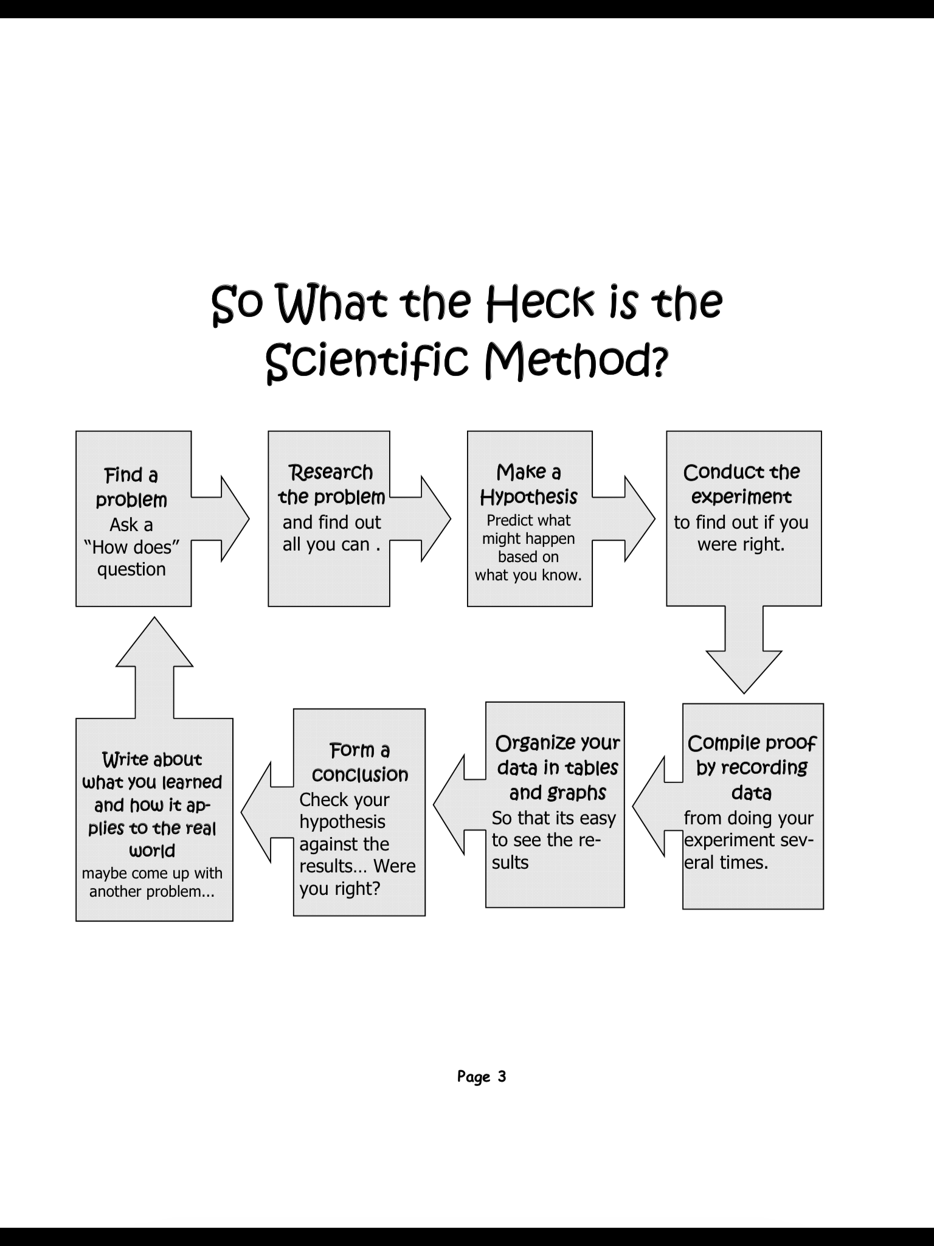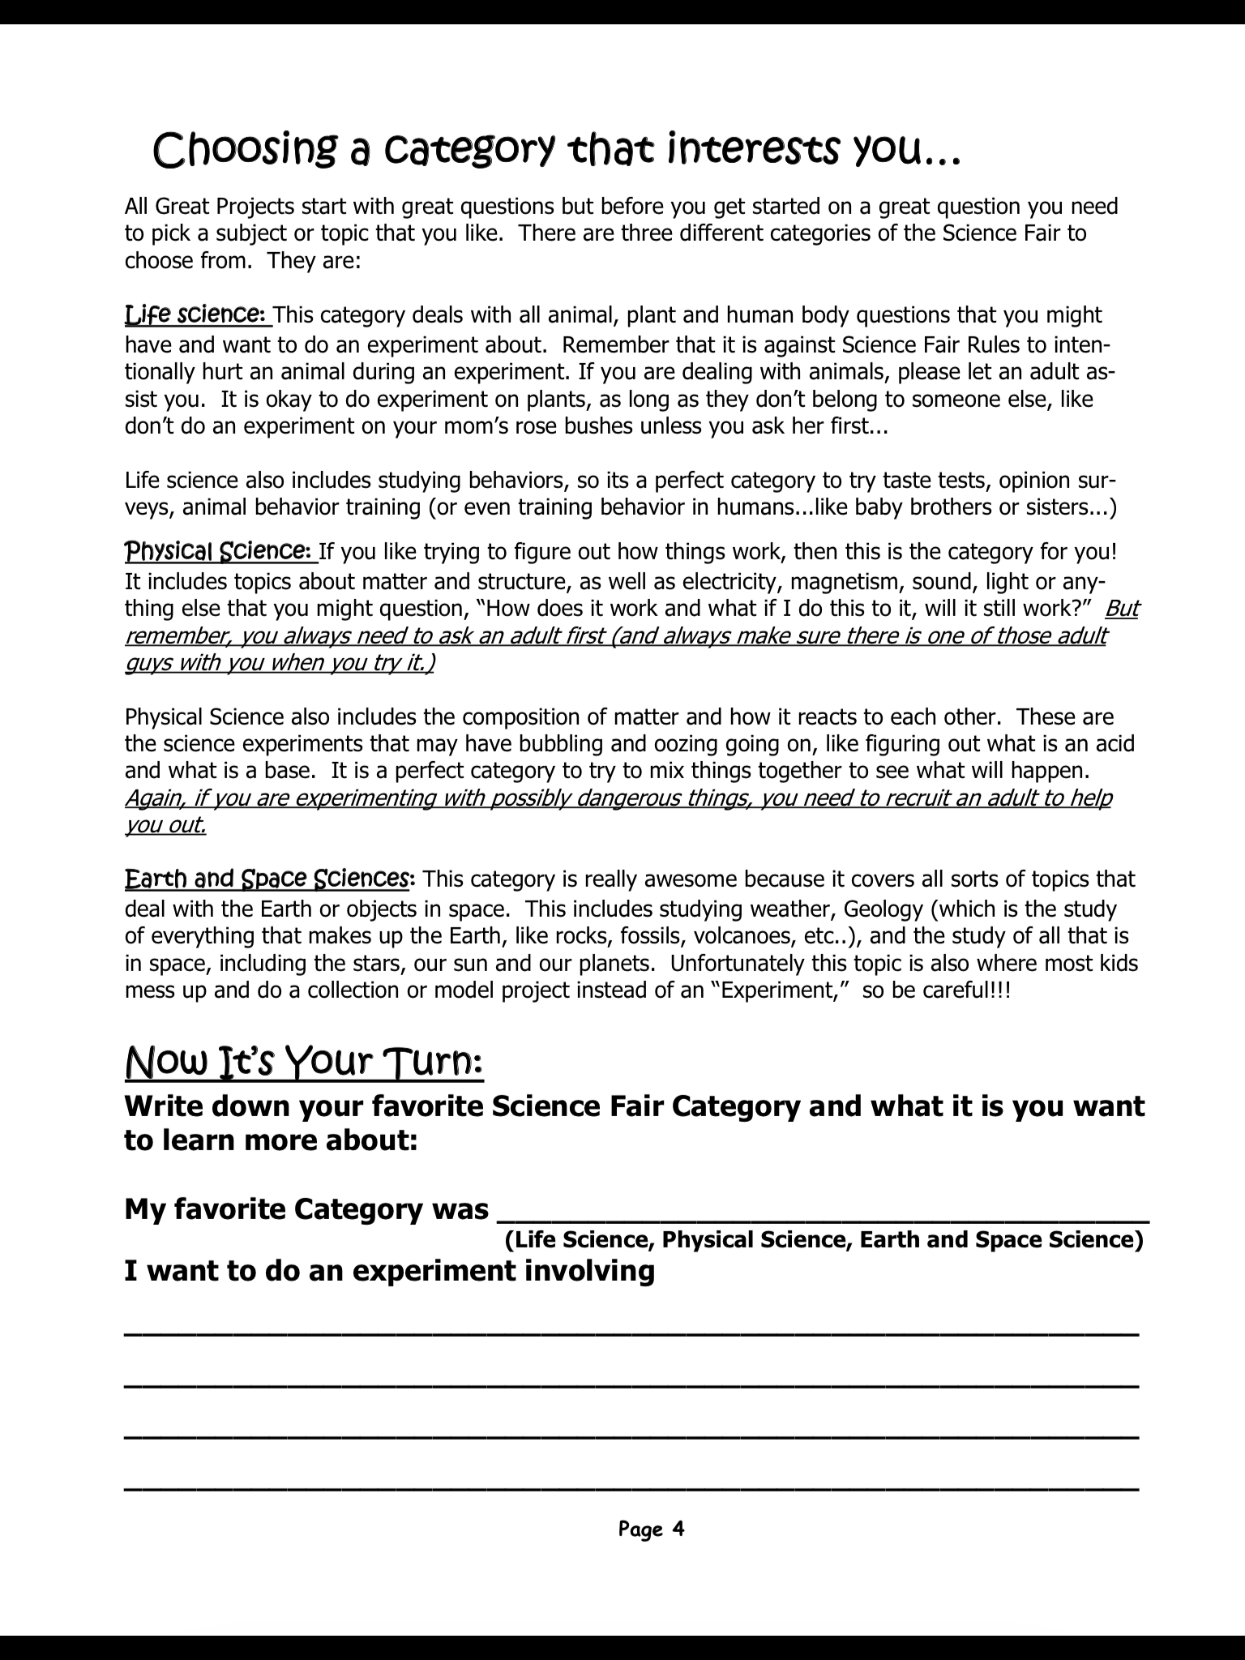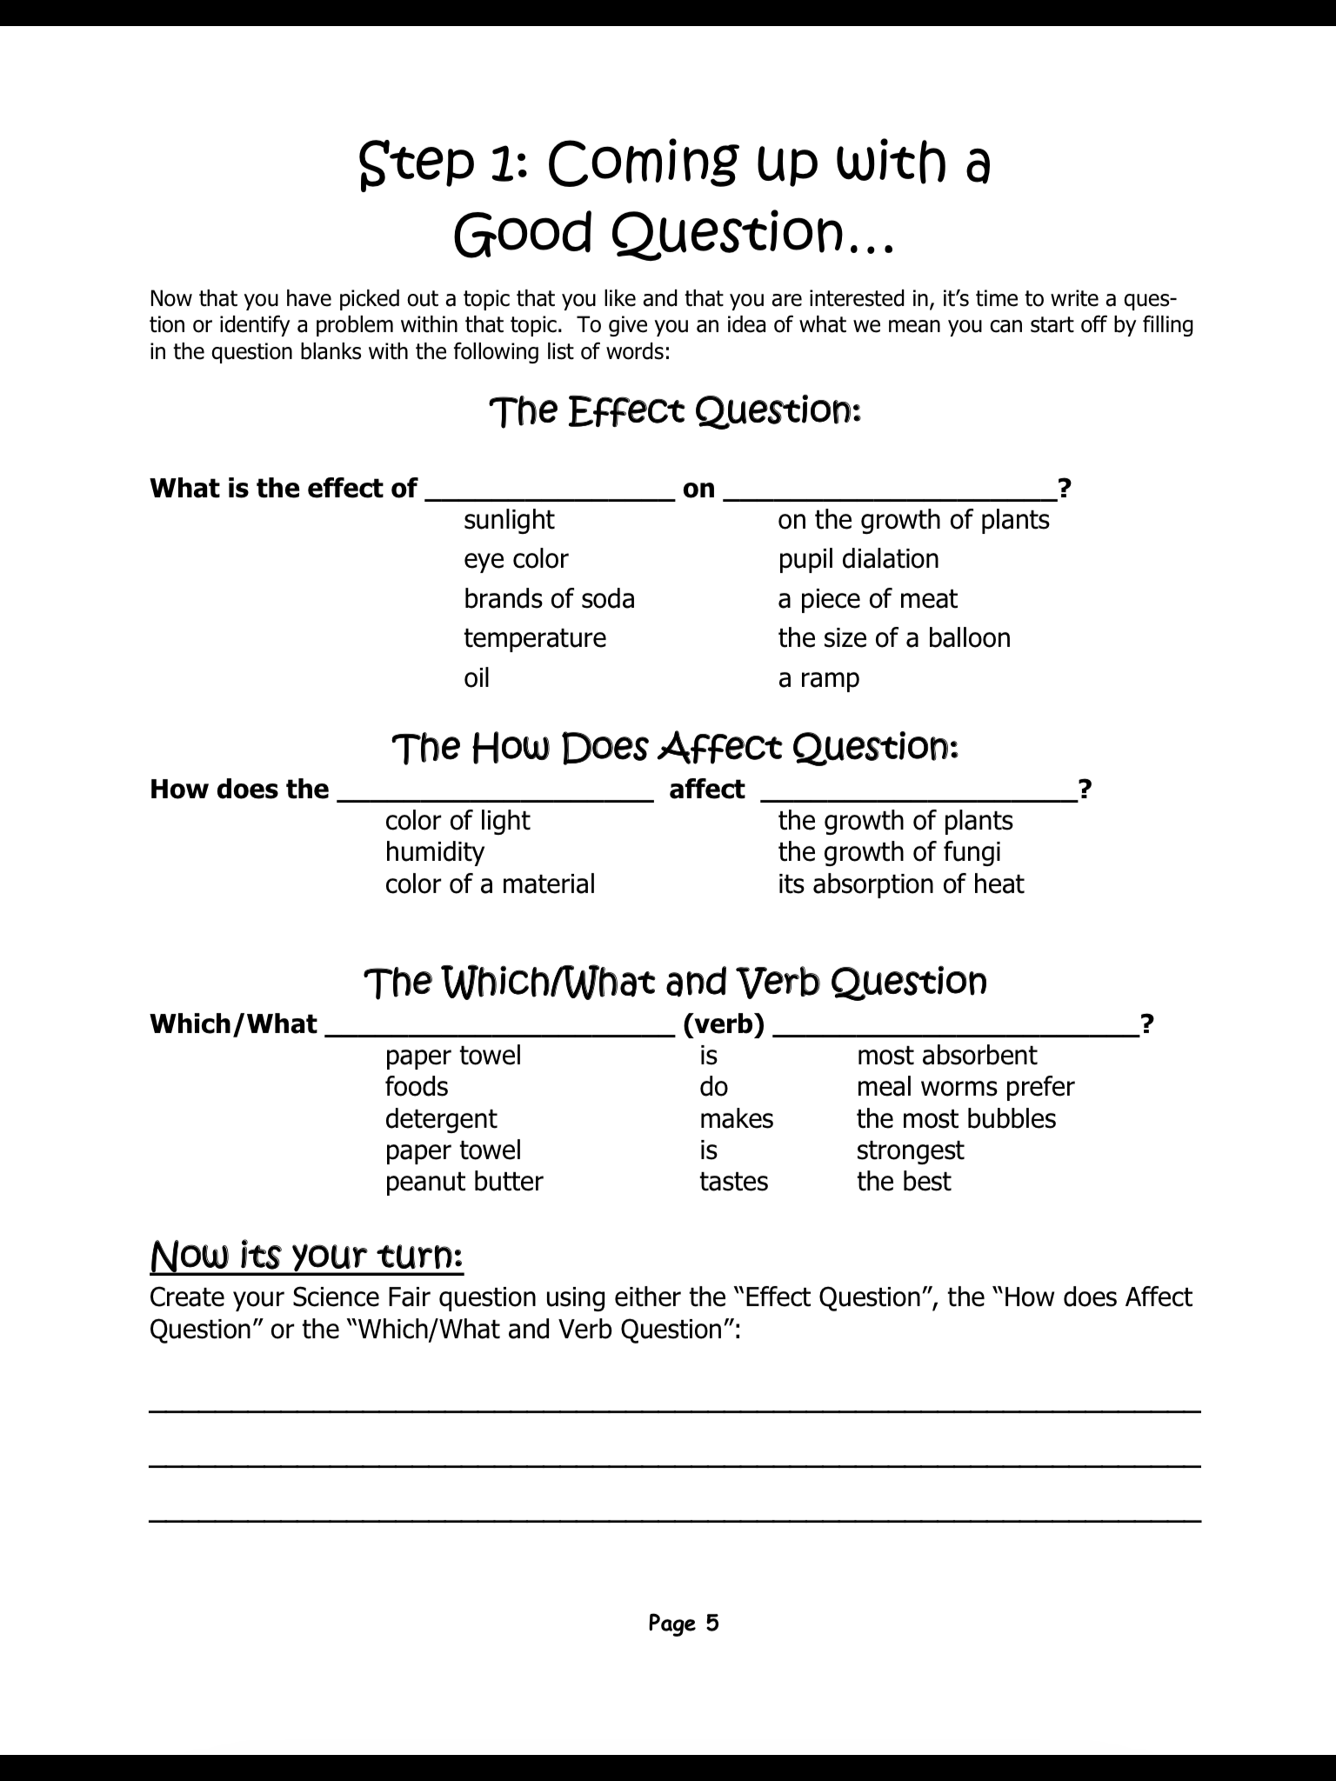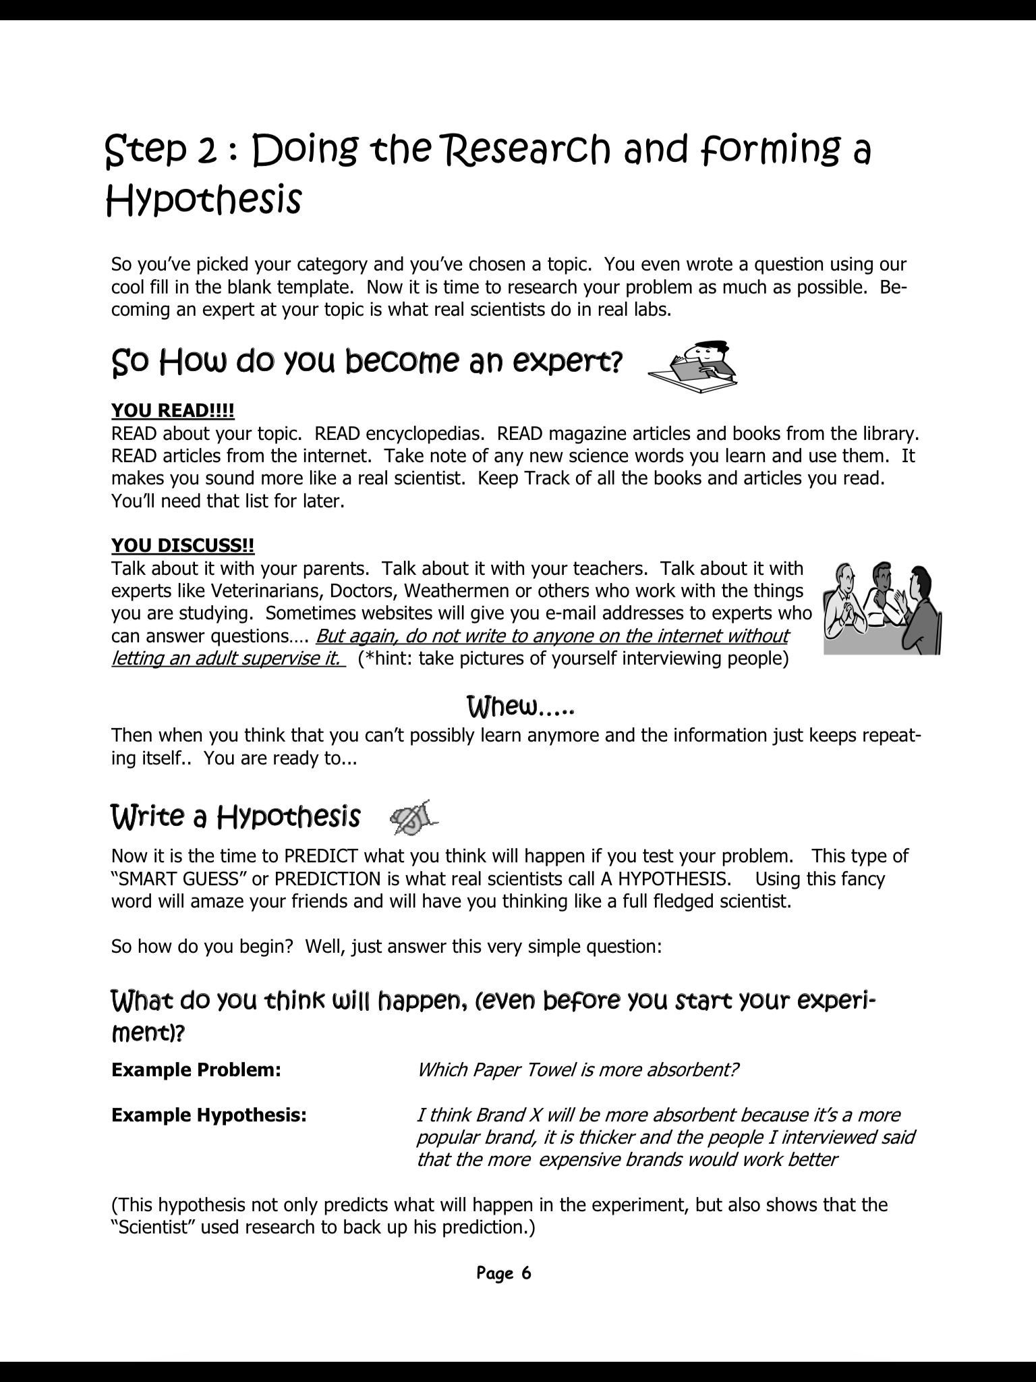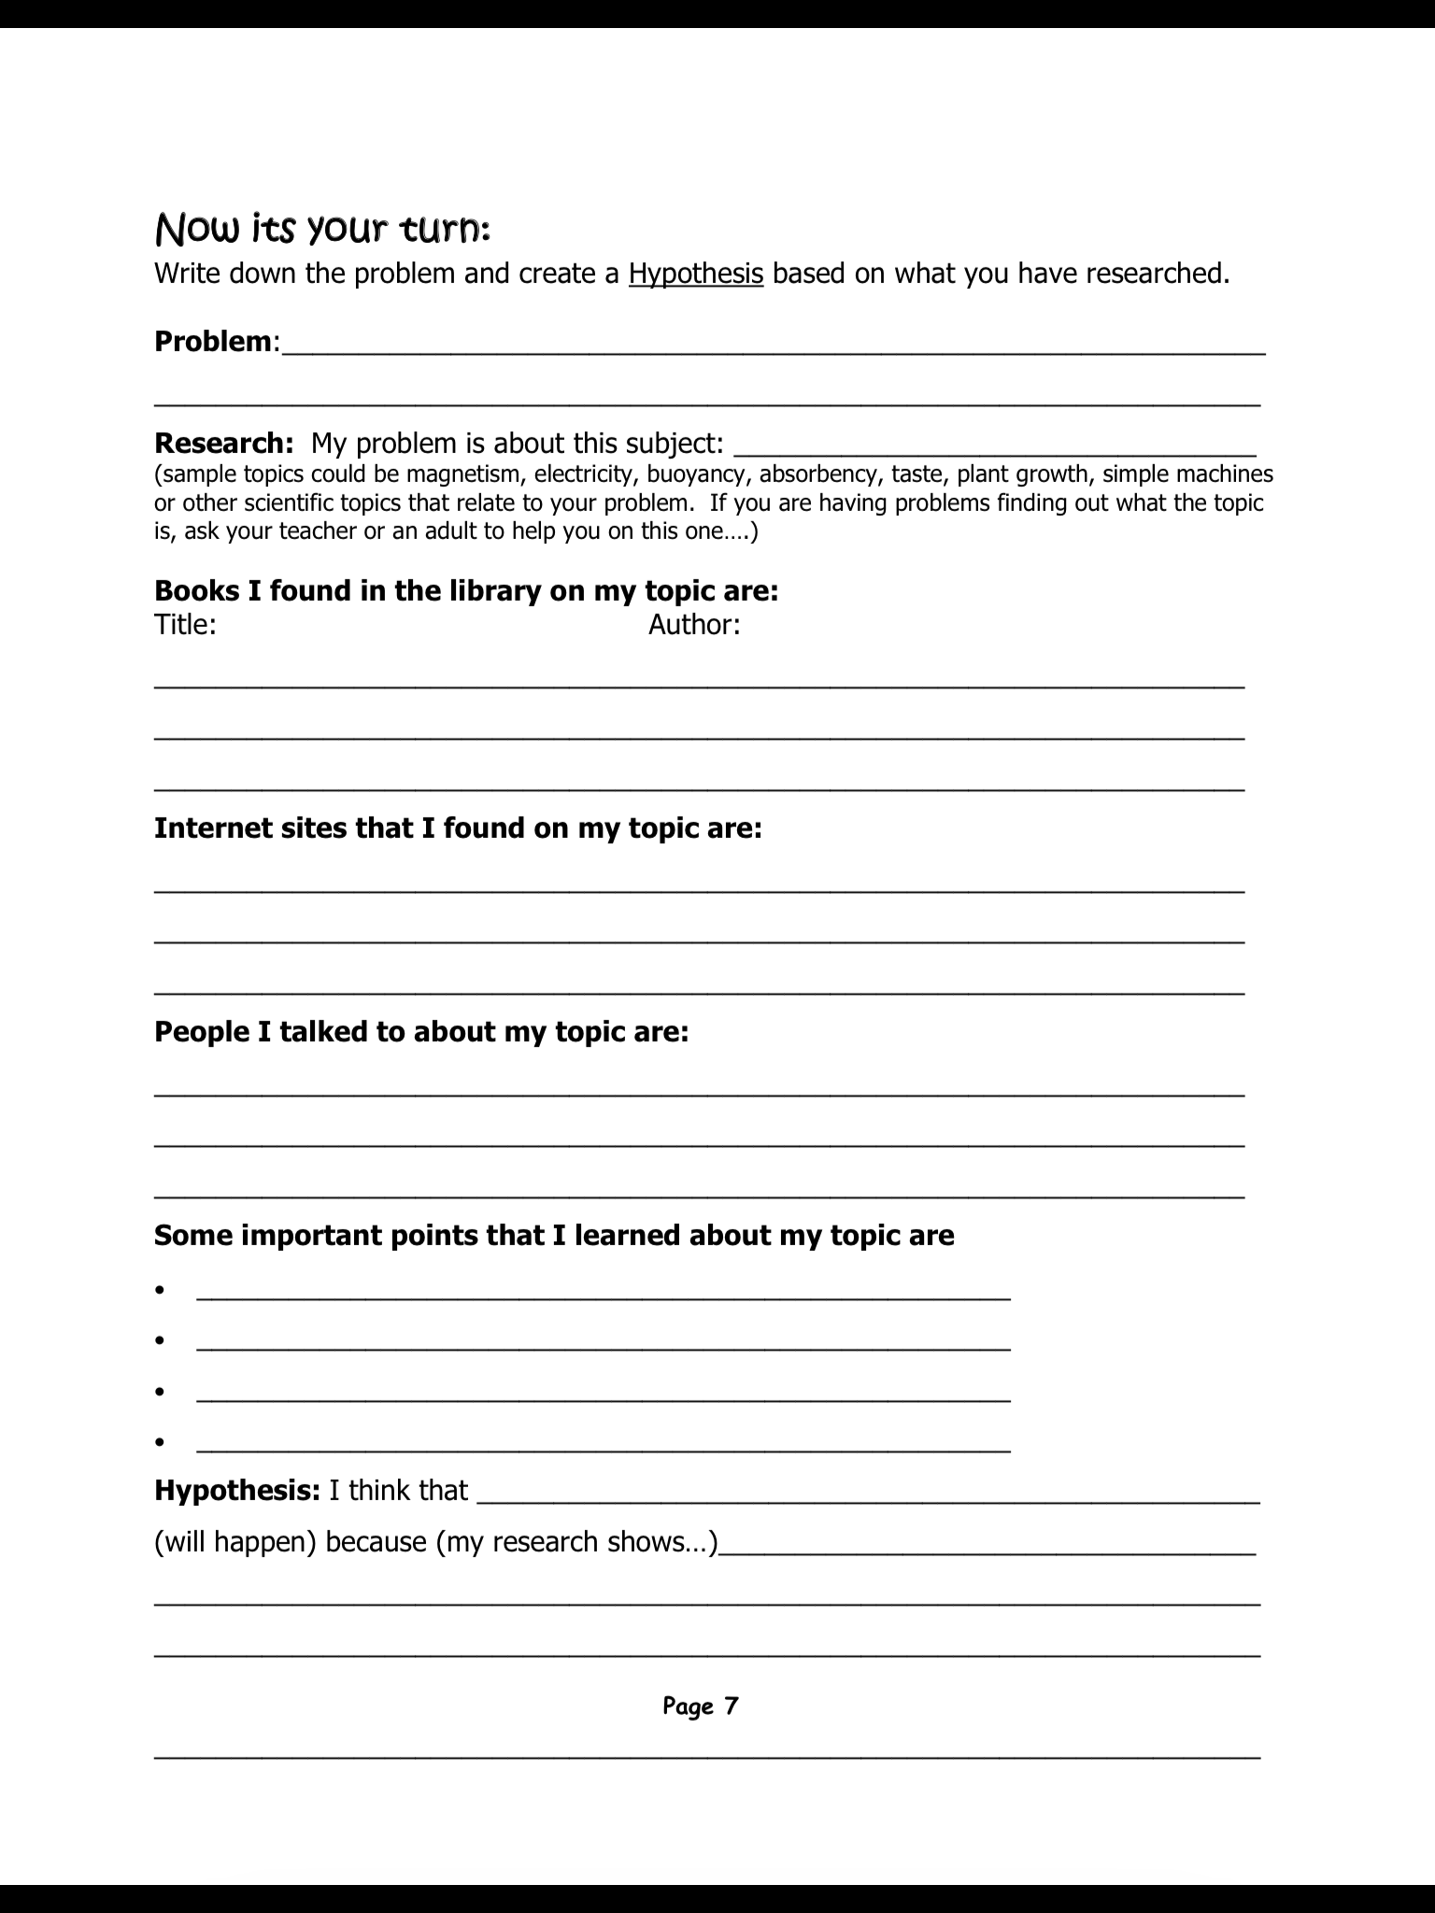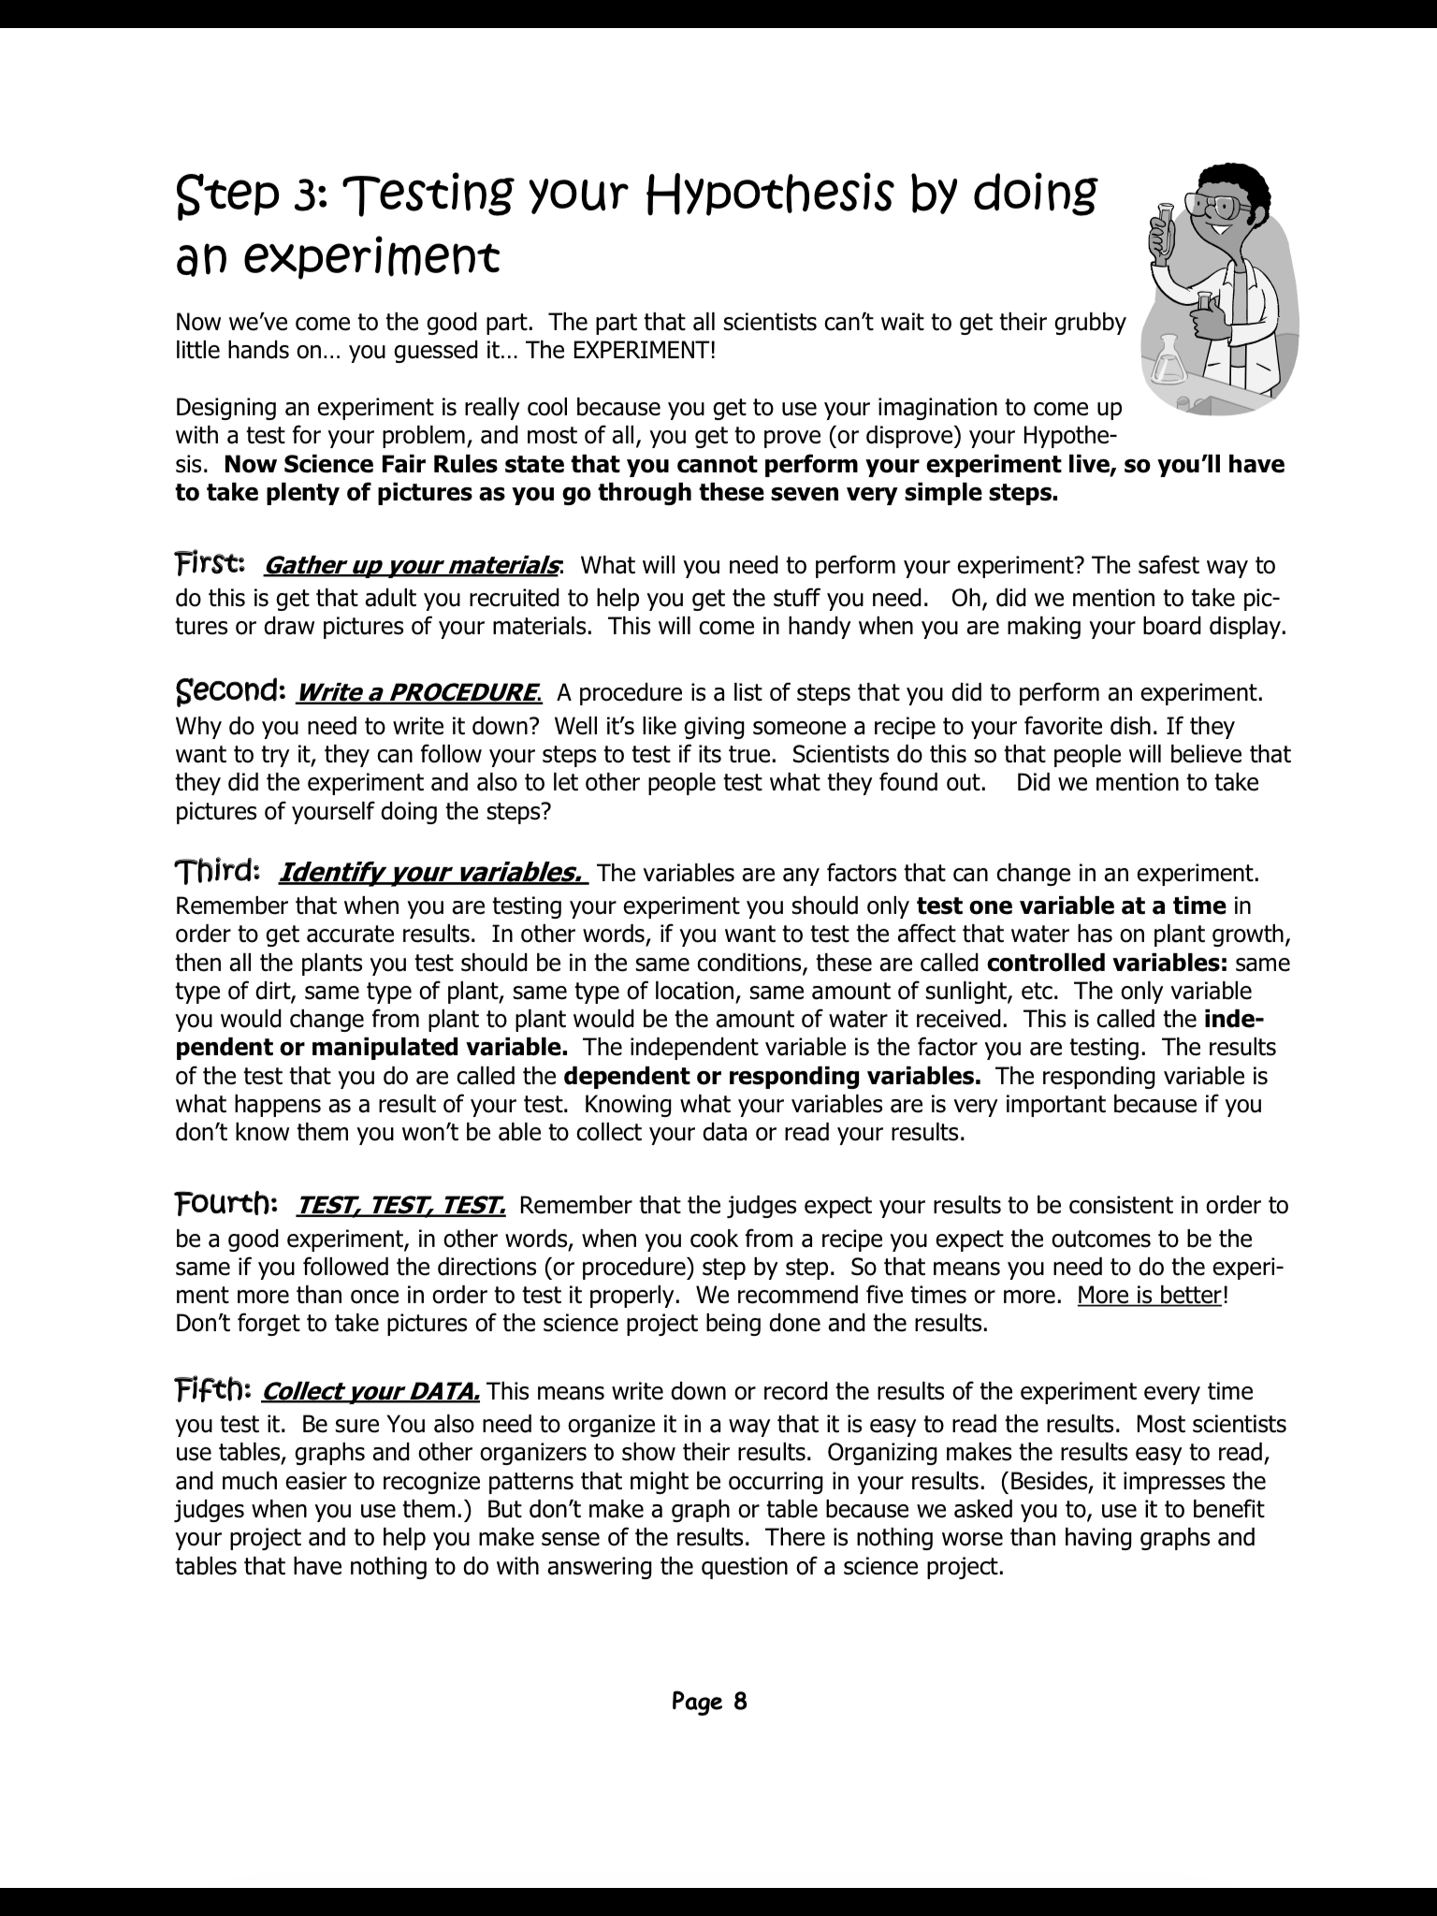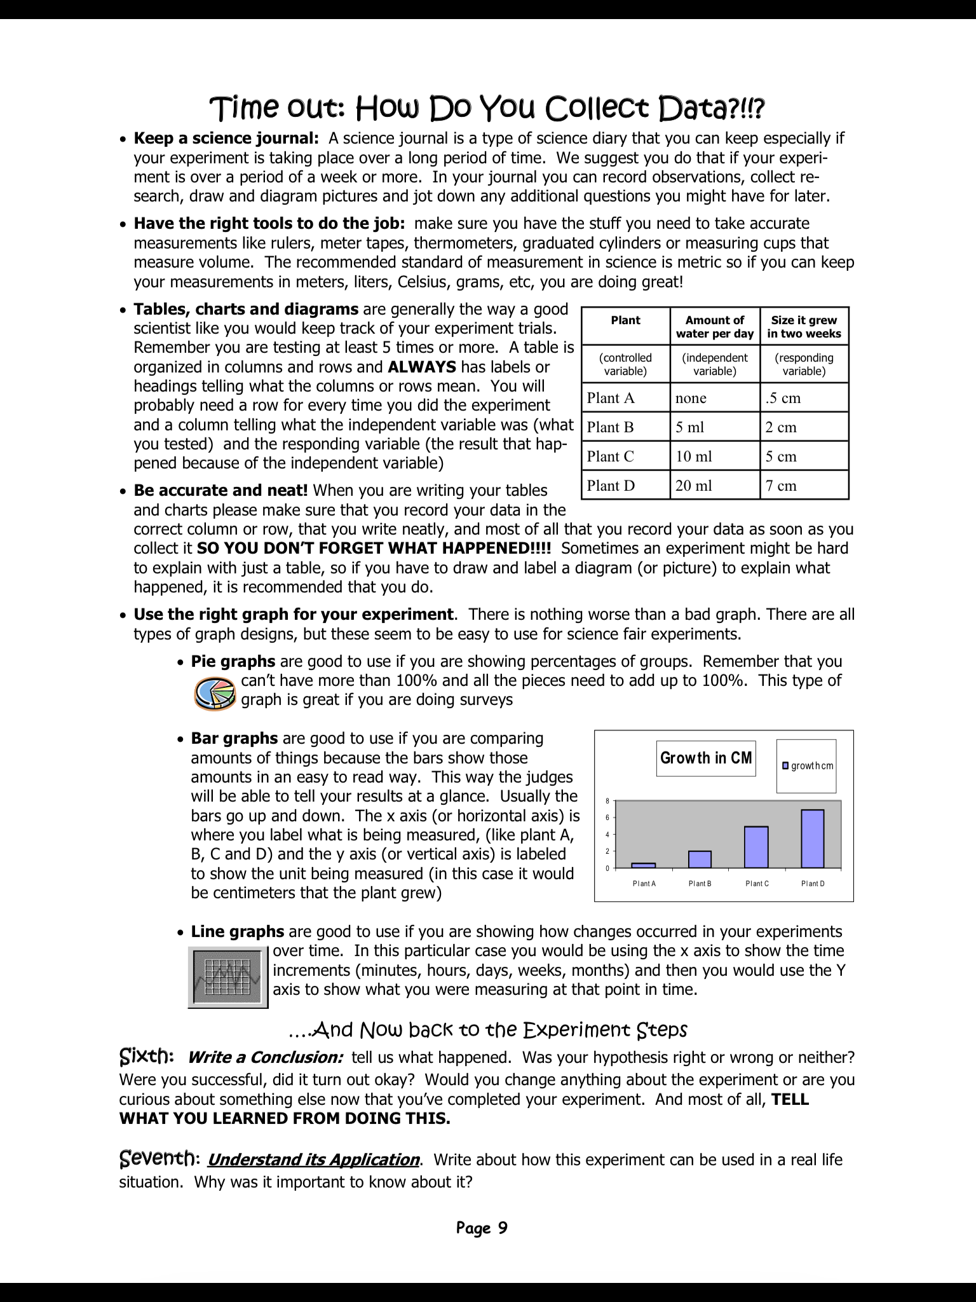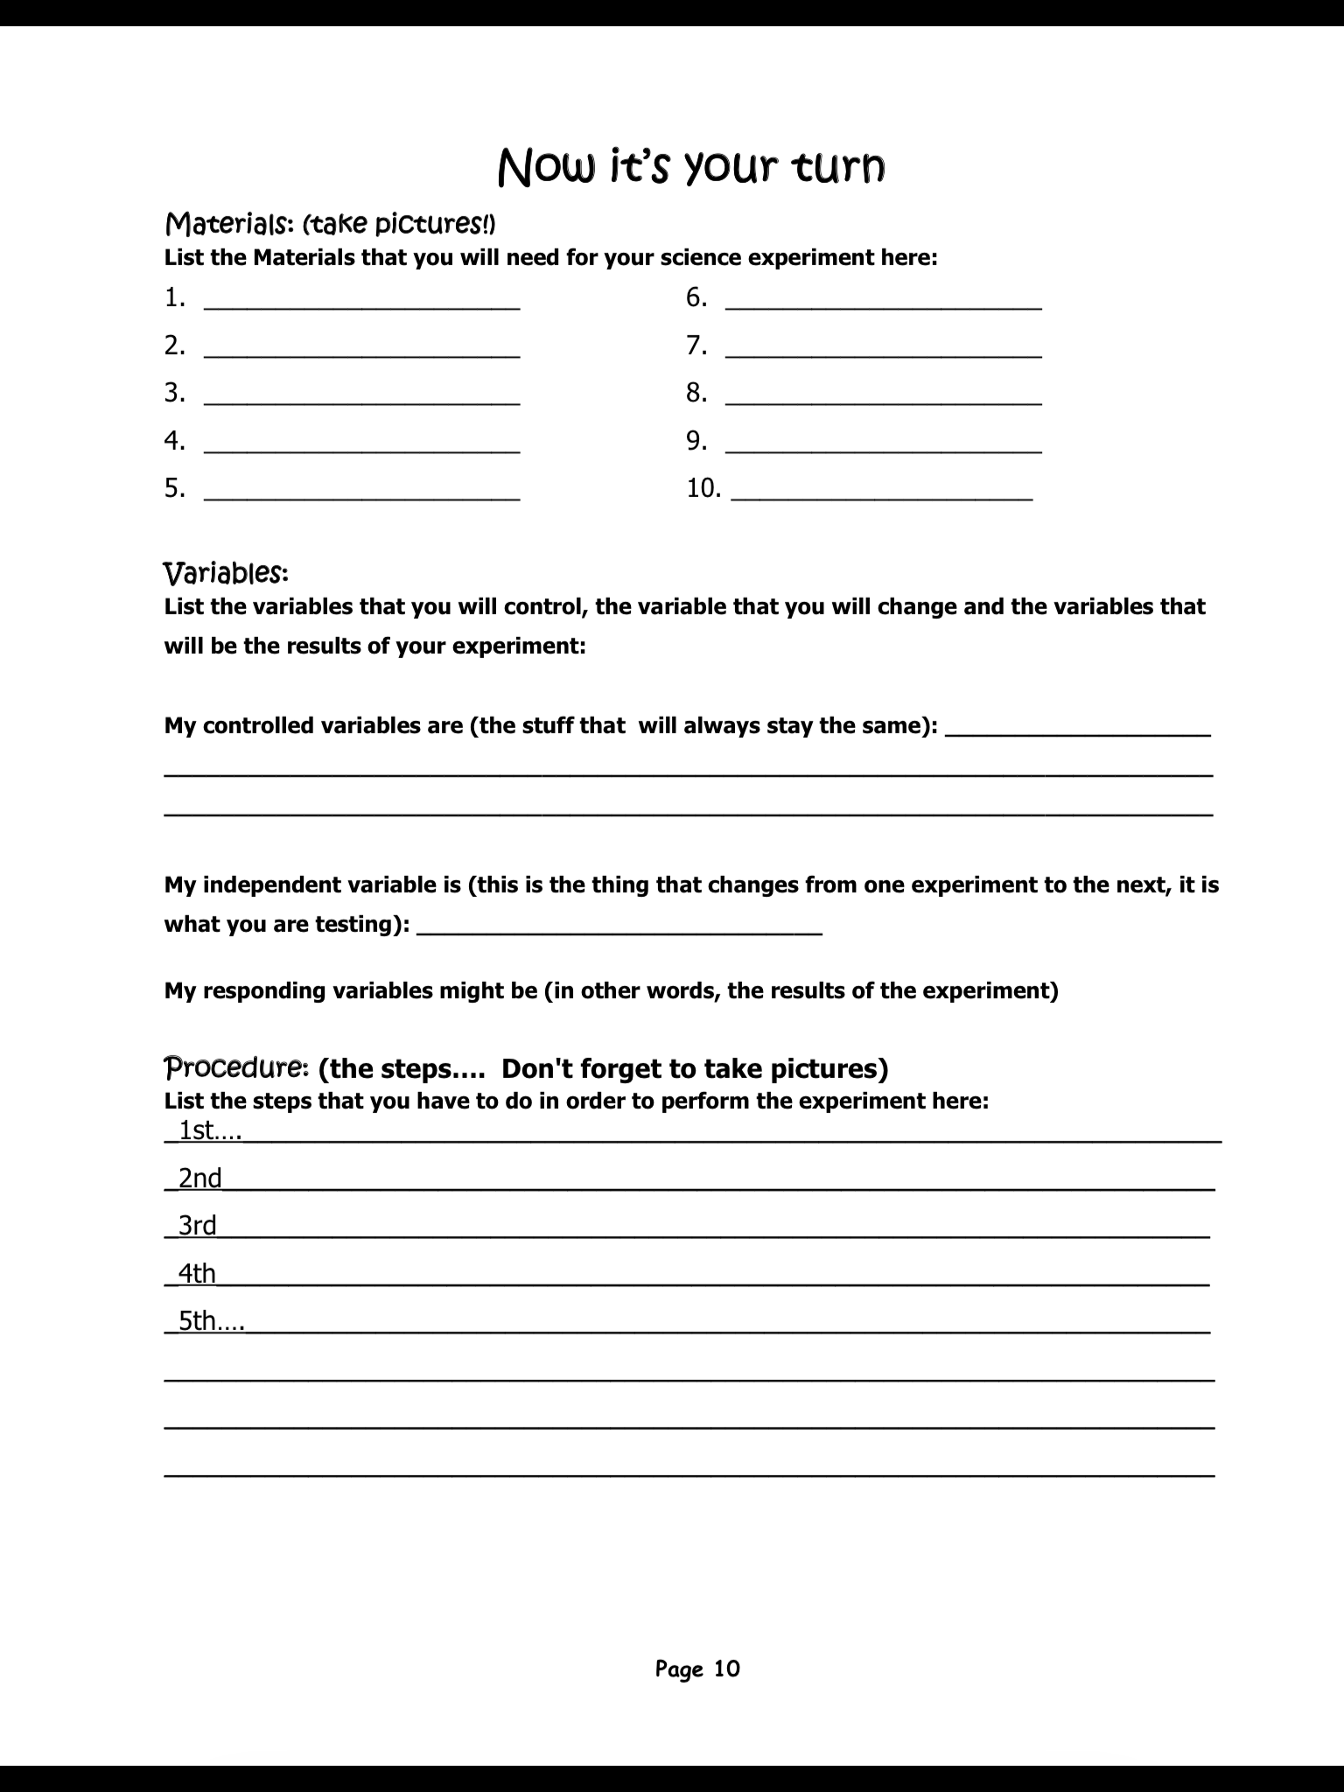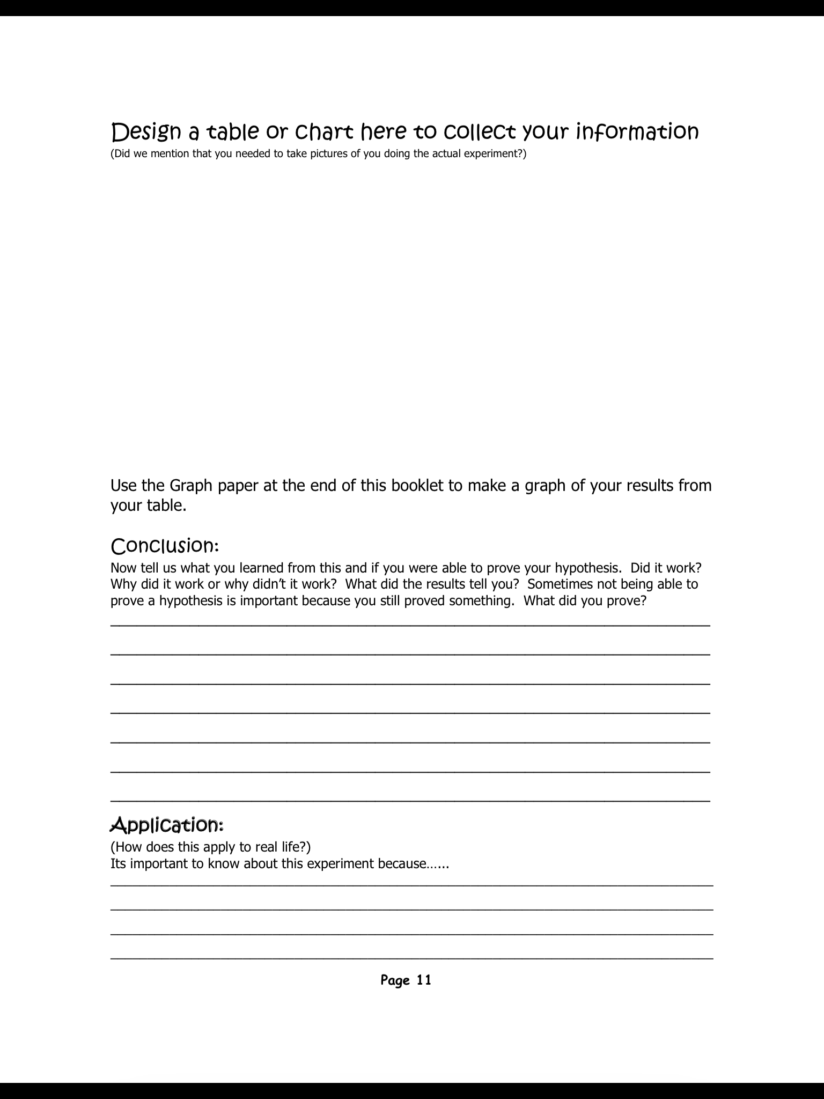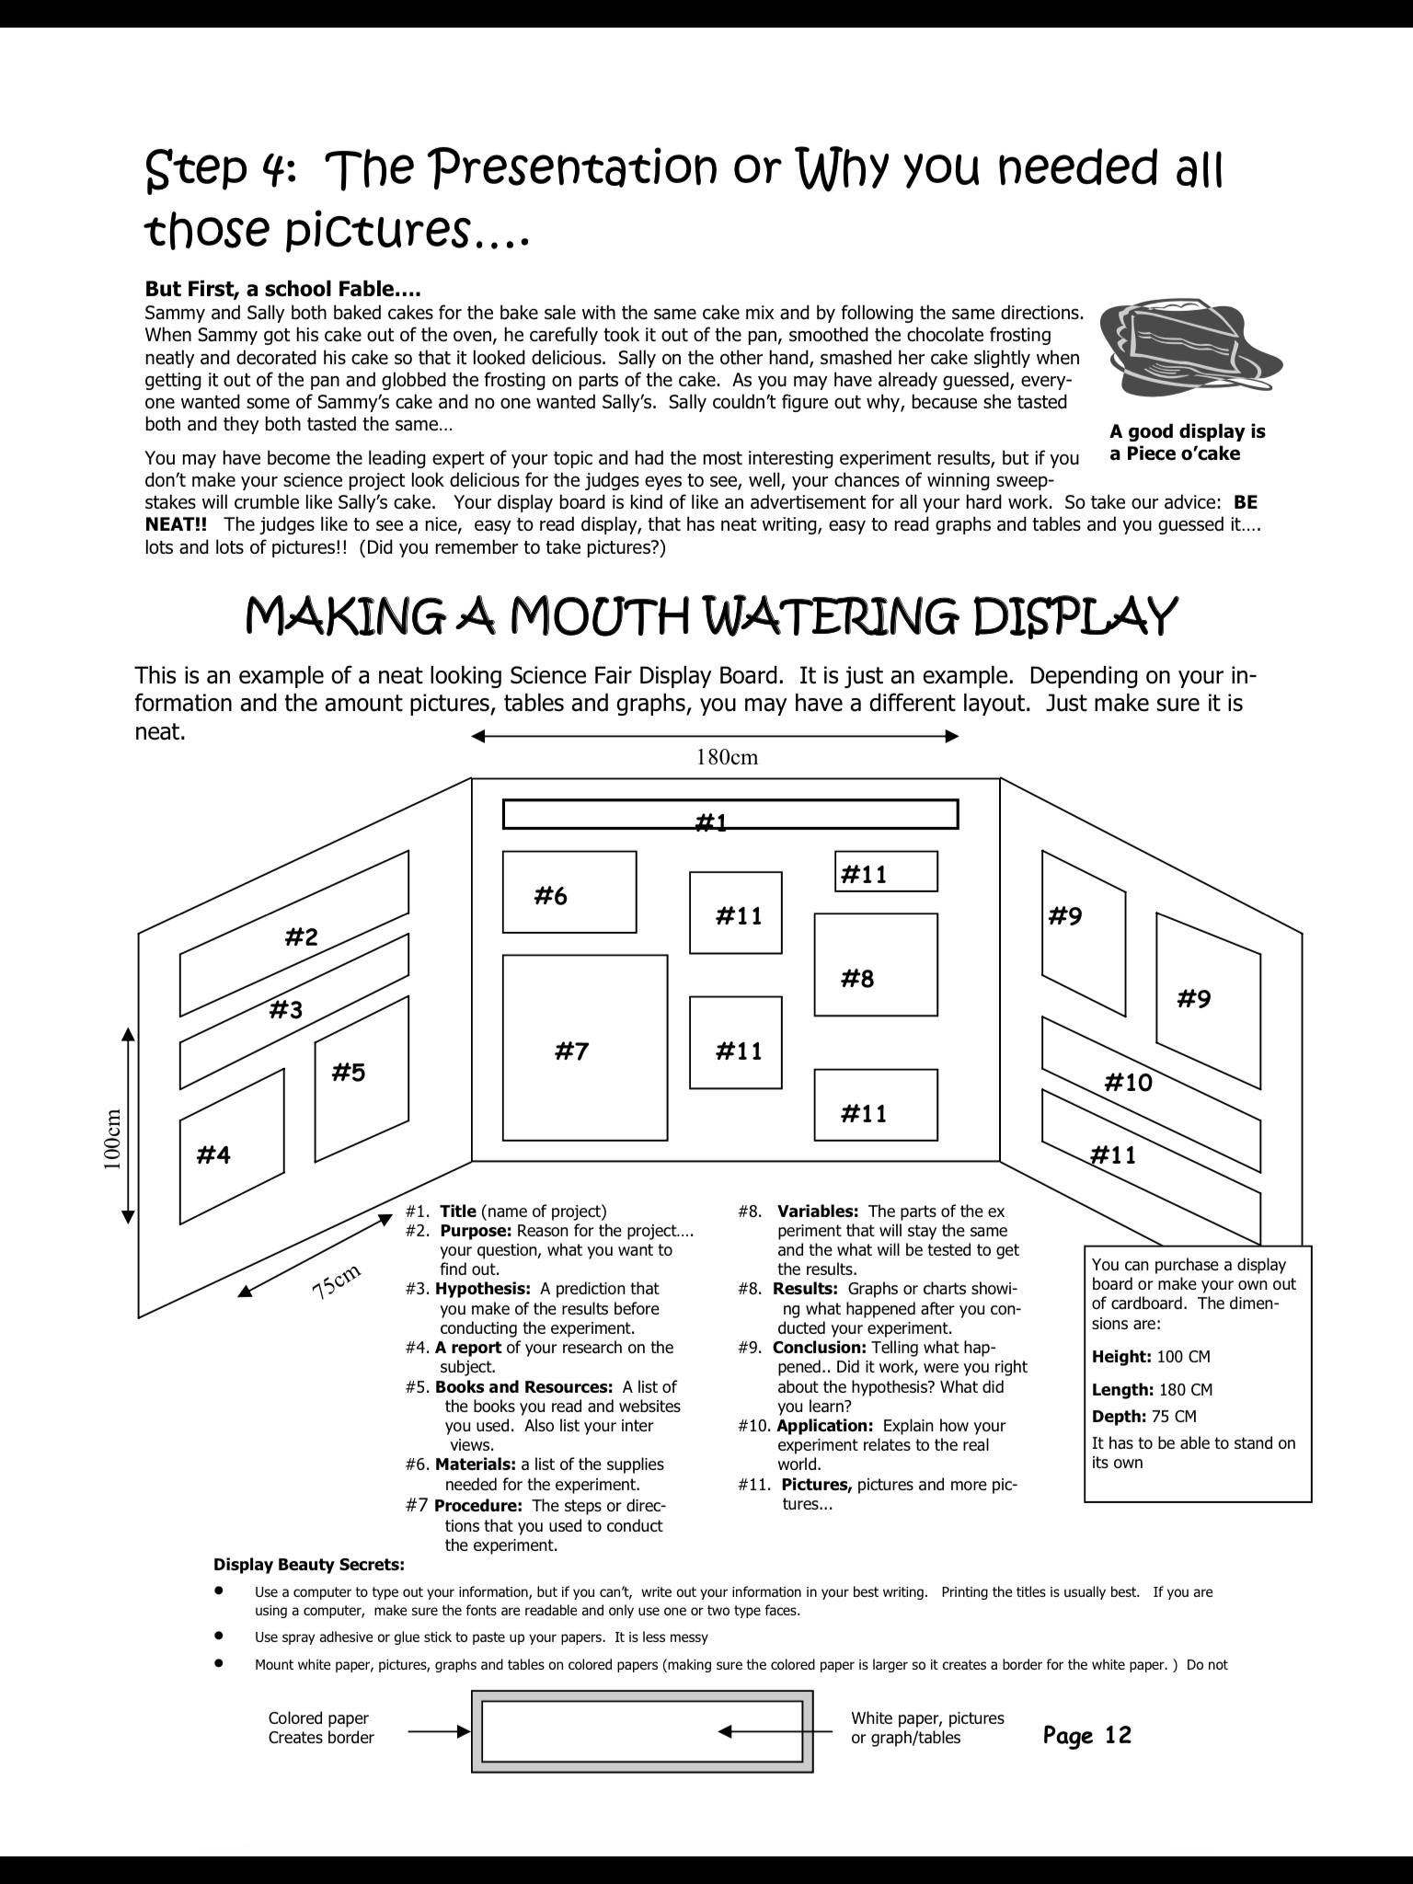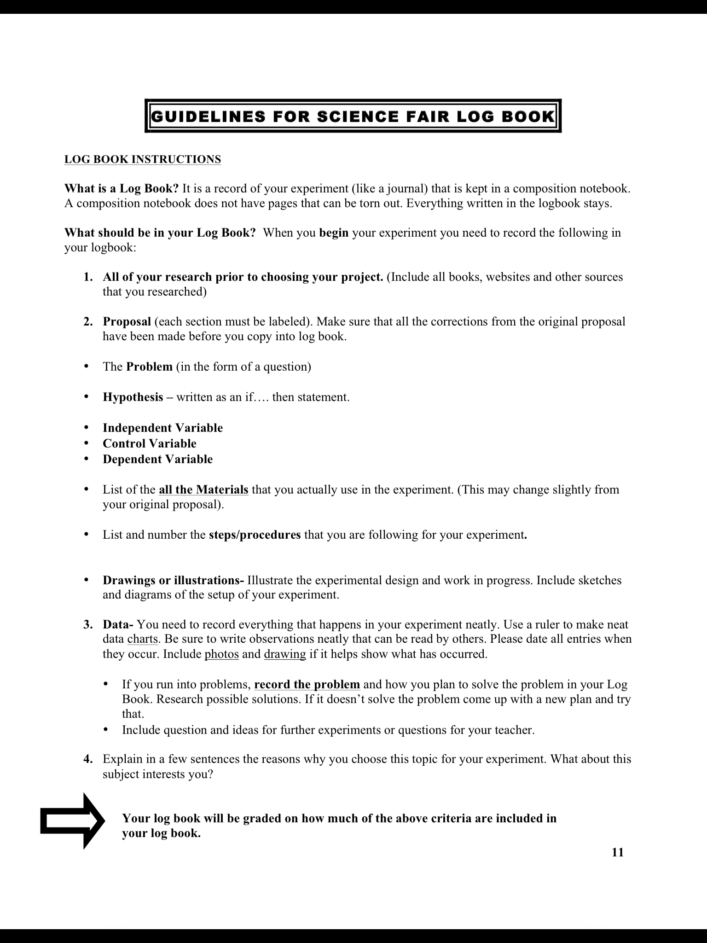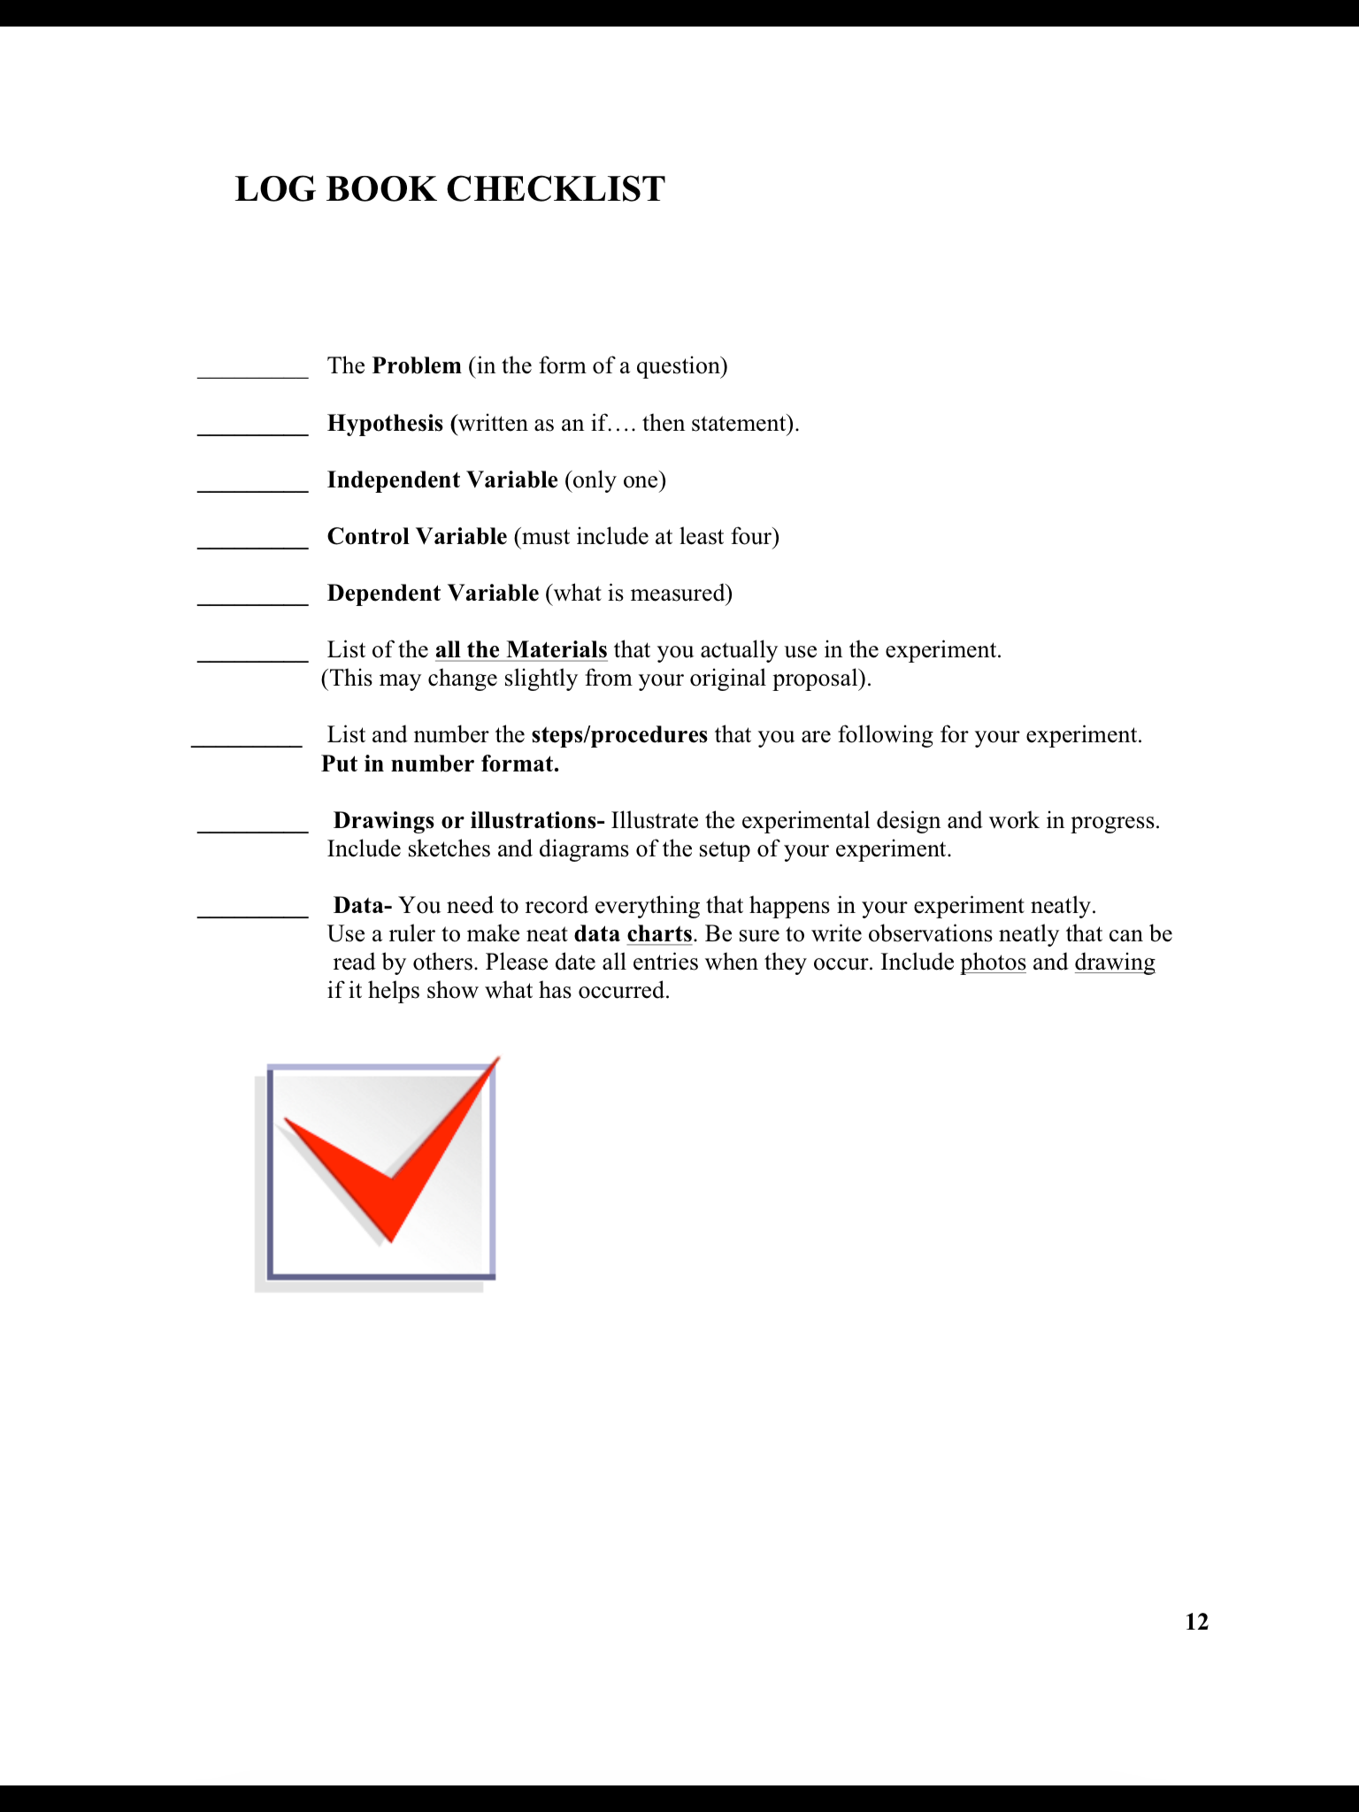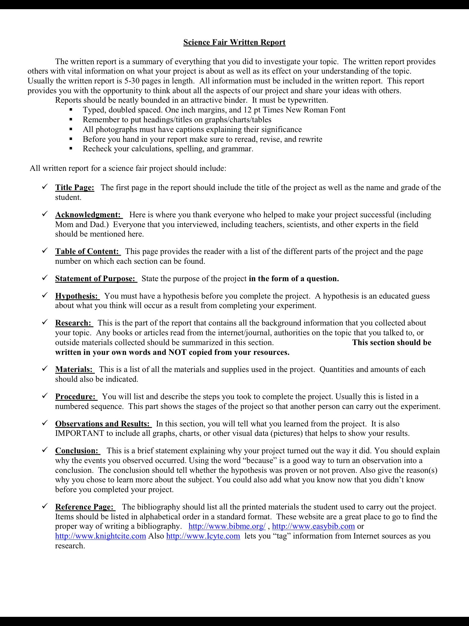

Science Project Grading Rubric

**POINTS** **Display**

____/15___ Is the display neatly organized and the design pleasing? (-1 to -5)

Are the Scientific Question, Hypothesis, Materials, Procedures, Results, and

Conclusion labeled? (-2 each)

Is there a Title If not, -5 Is it in the proper location? (-1 each)

Is the student’s name and class number below the Title? (-1 each)

Is the teacher’s name and grade level below the Title? (-1 each)

Are there at least 3 appealing pictures that pertain to the experiment? (-1 each)

____/10___ **Scientific Question**

Is there a Scientific Question? (-10)

Is the Scientific Question labeled? (-2)

Is the Scientific Question in the proper location? (-1)

Does the question end with a “?” (-1)

Does the question make sense? (-1 to -5)

____/10___ **Hypothesis**

Is there a Hypothesis? (-10)

Does the Hypothesis end with a period? (-1)

Does the Hypothesis relate to the experiment performed? (-1 to -7)

Does the Hypothesis answer the scientific question? (-5)

Does the Hypothesis make sense? (-1 to -5)

____/10___ **Materials**

Is there a list of materials? (-10)

Is the list of materials in the proper location? (-1)

Is it difficult to read the list? (-2)

Are all the items included that were necessary for the experiment? (-2 each)

____/10___ **Procedures**

Is there a list of procedures (-10)

Is the list of procedures in the proper location (-1)

Are the procedures numbered? (-2)

Does the list have fewer than 5 procedures? (-2 each <5)

Does each procedure make sense? (-1 per confusing procedure)

Can the list be followed to replicate the experiment? (-1 to -4)

Is the “Gather all materials” your first procedure? (-1)

Is “Record results” your last procedure? (-1)

____/10___ **Results**

Are the results on the board? (-10)

Are the results in the proper location? (-1)

Are the results displayed in table or graph form? (-9)

Are the results easy to read? (-3)

Is the table or graph constructed accurately? (-10)

If GRAPH, is the Y axis properly labeled (-2 partial, -4 not at all)

If GRAPH, is the X axis properly labeled (-2 partial, -4 not at all)

If TABLE, is the table properly labeled? (-4 partial, -8 not at all)

____/5___ **TRIALS**

Is there evidence of at least 3 experimental trials? (-1 for each missing trial)

____/10___ **Conclusion**

Is there a conclusion? (-10)

Is the conclusion in the proper location? (-1)

Does the conclusion end with something other than period? (-1)

Does the conclusion respond to the question? (-2 to -5)

Does the conclusion fit given the hypothesis? (-2 to -5)

____/10___ **Background Information**

Is there Background Information? (-10)

Is the Background Information in the proper location? (-1)

Is the Background Information clearly labeled using headings? (-1)

Does the Background Information speak to the experiment topic? (-1 to -9)

____/5___ **Bibliography**

Is there a bibliography? (-5)

Is the bibliography in the proper location? (-1)

Is the bibliography clearly labeled? (-1)

Is the bibliography accurate? (-1)

____/5___ **Log or Journal (on table in front of the display)**

Is there a log or journal included (scientific notes)? (-5)

Is the log hand written? (-1)

Is the log or journal clearly labeled? (-1)

Does the log or journal include all results reported regarding the experiment? (-1 to -3)

_________ **Further Questions** – Extra Credit (+1 to +5)

Explanation of extra points _____________________________________________________________________________________________________________________________________________________________________________

____ _____ **Total Points (possible 100)**

NOTE: Please check your work for spelling errors! 1-3 points will be deducted for spelling errors in each section depending upon the number and if the error is in the title/heading or simply in the body of the written work for that section. These deducted points will have a “sp” and or -___ to denote that spelling errors caused the deduction.